# K-Means Clustering

# Step 1: Import libraries
import matplotlib.pyplot as plt
from sklearn.datasets import load_iris
from sklearn.cluster import KMeans
from sklearn.preprocessing import StandardScaler

# Step 2: Load the dataset
iris = load_iris()
X = iris.data[:, :2] # Sepal length and sepal width

print("Dataset shape:", X.shape)

# Step 3: Standardize the data
scaler = StandardScaler()
X_scaled = scaler.fit_transform(X)

# Step 4: Apply the Elbow Method
inertia = []

for k in range(1, 11):
model = KMeans(n_clusters=k, random_state=42, n_init=10)
model.fit(X_scaled)
inertia.append(model.inertia_)

# Step 5: Plot the Elbow graph
plt.plot(range(1, 11), inertia, marker='o')
plt.xlabel("Number of Clusters (K)")
plt.ylabel("Inertia")
plt.title("Elbow Method")
plt.show()

# Step 6: Apply K-Means with K = 3
kmeans = KMeans(n_clusters=3, random_state=42, n_init=10)
clusters = kmeans.fit_predict(X_scaled)

# Step 7: Visualize the clusters
plt.scatter(
X_scaled[:, 0], X_scaled[:, 1],
c=clusters, cmap='viridis', s=50
)

plt.scatter(
kmeans.cluster_centers_[:, 0],
kmeans.cluster_centers_[:, 1],
marker='X', s=200, color='red', label='Centroids'
)

plt.xlabel("Standardized Sepal Length")
plt.ylabel("Standardized Sepal Width")
plt.title("K-Means Clustering (K = 3)")
plt.legend()
plt.show()

# Step 8: Display cluster assignments
print("\nFirst 10 cluster assignments:")
print(clusters[:10])

How does the Elbow Metho d work?
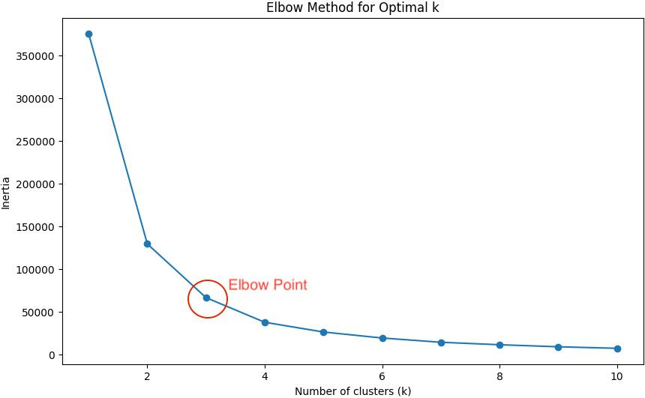
The Elbow Method helps identify a suitable value of \(K\), the number of clusters.
- X-axis: Number of clusters (\(K\)).
- Y-axis: Inertia, which is the sum of squared distances between data points and their assigned cluster centers.
- As \(K\) increases, inertia generally decreases.
- Choose a value near the point where the decrease begins to slow significantly. This is called the elbow point.
The optimal value is not always exactly 3. In this program, \(K=3\) is chosen for demonstration; students should examine the elbow graph before selecting their final value.
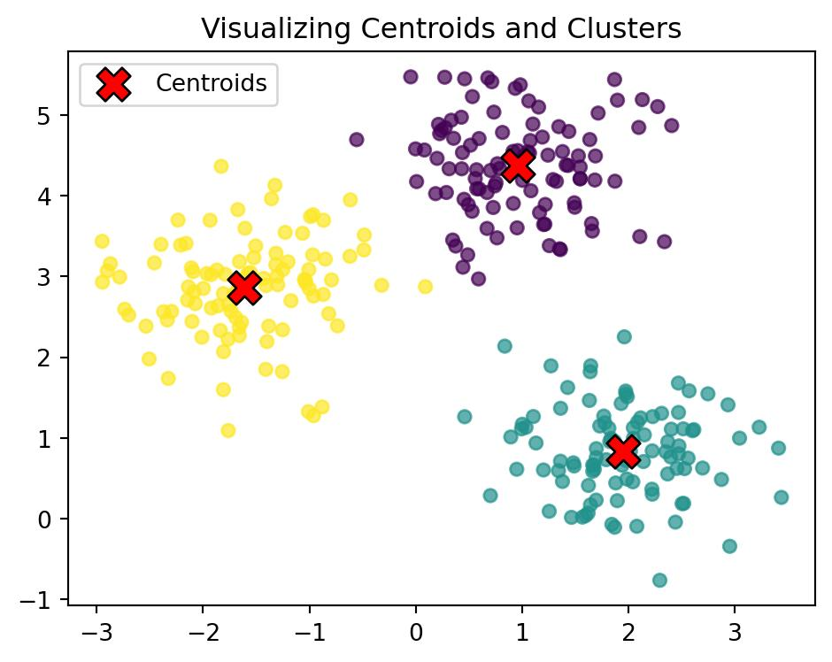

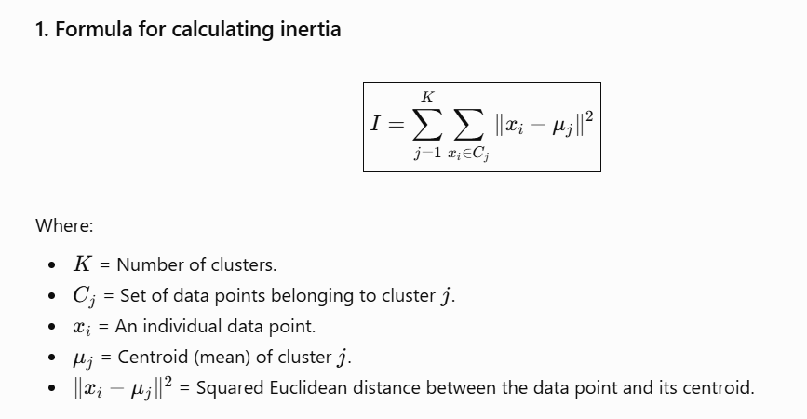

Cluster 1
Study hours: 2, 3, 4
Centroid = (2 + 3 + 4) / 3 = 3 hours
Data point | Distance from centroid | Squared distance
2 | 2 − 3 = −1 | 1
3 | 3 − 3 = 0 | 0
4 | 4 − 3 = 1 | 1
Cluster 1 inertia = 1 + 0 + 1 = 2
Cluster 2
Study hours: 7, 8, 9
Centroid = (7 + 8 + 9) / 3 = 8 hours
Data point | Distance from centroid | Squared distance
7 | 7 − 8 = −1 | 1
8 | 8 − 8 = 0 | 0
9 | 9 − 8 = 1 | 1
Cluster 2 inertia = 1 + 0 + 1 = 2
Total inertia = 2 + 2 = 4

